TECHNICAL DATASHEET

Product Details

Make : SUDEEP
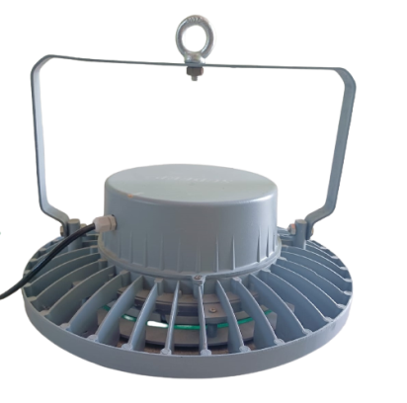
Model : SEHBLW200
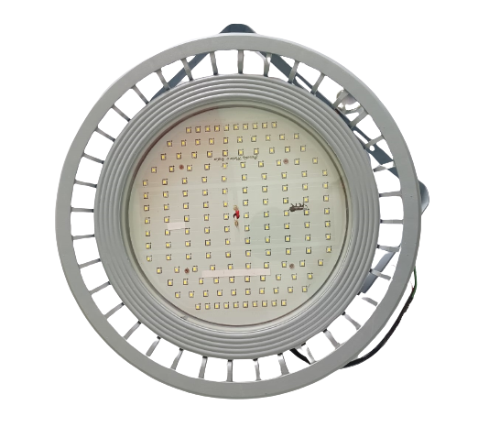
Series : LED High Bay Light

Electrical Data

Input Voltage Range : 140 - 270 VAC
Power : 200 Watt
Power Factor : >0.95
Frequency : 50/60 Hz
Protections : THD < 10%
Driver : Constant Current Active
Power Factor Corrected
Lumens O/P : 13000 Lm

Light Data

LED Efficacy : 1 lm/Watt
Beam Angle : 80 ⁰
CCT : 6000 K +/- 100
Environmental

Working temperature : -10 to +60 Deg. Cel.
Working humidity : 10 to 90%
IP rating : IP65
Protection : IK07
Surge Protection : 5KV (Internal),
10KV (External)

CRI : >70
LED Make : Osram
LED Type : SMD 2835
LED Life Time : 50,000 hours

Size

Dia x H : $∅$ 380 x 130 mm
Warranty : 3 Years
Body Colours : Grey, Black

Applications

Manufacturing Plants, Shop Floor, Industrial Areas, Godown, Shops, Warehouses, Storage Units

